STUDENT Joseph Roper

Salford City College | [Company address]

BTEC National 90 Credit Diploma in Creative Media Production

Unit 78: Digital graphic for computer games

Contents

Generating Concept Ideas 3

Stimulus 3

Client Brief 3

Own Brief 3

Market Research 3

Legal and Ethical Considerations 4

Copyright/ Plagiarism 4

Libel 4

Females in Video Games 5

Ethnicity and Diversity 5

Religion 5

Intellectual Property 6

Computer Game Graphics 6

Raster 6

Vector 6

Head up display 6

Sprites 7

Concept Art 8

Graphic Specification 8

Client Needs 8

Audience 8

Visual Style 8

Technical Considerations 11

Scheduling 14

Version 2 15

Game Evaluation 0

Game Ideas 1

Shanty Town Game Mood Board 1

Story Board 3

Idea Generation 4

Brainstorming 4

Mood Board 5

Thumbnail Sketching/Storyboard 5

Planning and Creation

# Generating Concept Ideas

## Stimulus

A stimulus is something that causes people to have ideas. For example, a stimulus for a game would be a mood board because I make people think about what he game could be.

### Client Brief

A client brief is a list given from an employer which is then usually turned into a schedule for the developers, the developers would then have to complete the work listed in that order. The client brief usually contains an initial objective, priority tasks and general things the employer would want implemented in the game.

The initial objective could be to create 3D models for the main characters in the game or at least concept art for them. The priority tasks would be things on the client brief that would need to be complete before the deadline, for example a fully working demo for people to play at a gaming convention or a trailer to be played at one.

### Own Brief

An own brief is a creator’s personal objective; it could be a pre-set task such as to complete a certain 3D model for a game, or an idea that they continue to alter and work on which could be the ending of a game which the developer is not set on.

### Market Research

Market research is needed in the games industry as it is finding out what the specific audience for your game is which is also known as the target market, and what your target market would like implemented in your game. This is so important as without it developers wouldn’t know what their audience liked and would probably produce a game that is not great as they didn’t tailor the game to their target market meaning the content of the game will not be liked by the players as it is not what they like.

Market research is when game companies are competing against each other, so they try to bring in a new audience for example with Sony and Microsoft with the Xbox One and the PlayStation 4. Sony projected the PlayStation 4 to "real gamers" this is seen from their slogan "This is for the players!" Whereas Microsoft initially marketed the Xbox one as a console for the family with its new TV function or something like that. Microsoft knew they had to one up their direct competitor by targeting the console at the family which is a broader market meaning potentially a bigger audience meaning more sales. Although it didn't work out for the Xbox One because of its terrible game line-up with hardly any exclusive titles but it's still an example of market research.

## Legal and Ethical Considerations

This is one of the most important things to do with making and producing a game as if you do something wrong such as copyright or you cross a line by representing a certain religion in a bad way you could ruin your game from the start causing people to outrage and not buy your game.

### Copyright/ Plagiarism

When producing a game there are regulations and codes of practice that must be constantly taken into consideration by the publishers and developers. Trademarks and copyright need to be looked at as well as if a developer is using someone else’s sound library they will have to ask the creator of the sounds if it is ok to use the sound in the game or if he must buy a license first. This is also needing to keep a game developer’s assets safe such as game characters, logo’s and box art which is protected by copyright. An example of this is if you were to make a game and use one of Nintendo’s characters such as Mario or Link without their permission they could sue you and take the game down. This has happened previously with a fan made Pokémon game called Pokémon Uranium but because the game called the pocket monsters Pokémon and called the catching devices Poke balls the game was copying the Pokémon franchise and invaded the copyright law and even though the game was free it was still taken down by Nintendo. From this I know not to use copyrighted assets in my game.

[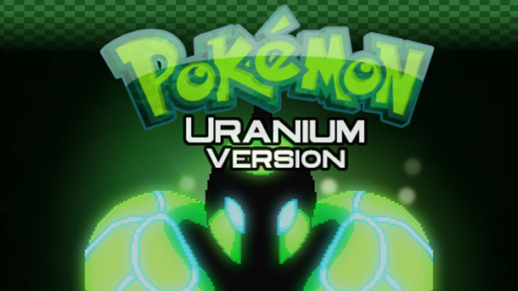](http://www.gameinformer.com/b/news/archive/2016/08/10/fans-come-together-to-create-the-original-unofficial-pok-233-mon-uranium.aspx)

### Libel

Libel is when a game developer will say something negative in a video game, this could be about another company or rival. Some companies will implement light slander in their games against other companies but this is not enough for them to be taken to court for. As if you said Ubisoft don’t pay their taxes in a video game Ubisoft would be able to take you to court if you couldn’t prove that the allegation was true. From this I have learnt to not take the risk and put libel in the game I will create.

### Females in Video Games

The reason for this being an ethical consideration is because usually when a female is in a video game they are sexualised. This is not really a problem nowadays but still woman in video games are still sexualised for example nearly every female character in the game Overwatch is wearing a skin tight costume such as with the characters Tracer and Widow. With the picture below of the character Tracer there was a lot of controversy as when the game was first released one of Tracers’ emotes was too sexualised this is the one which faces her back, this was then changed to the other emote because people complained that it was too sexual. From this I have learnt that I should treat Females and makes the same in games and not overly sexualise characters in the game I make.

[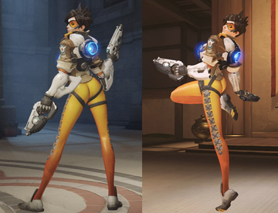](https://en.wikipedia.org/wiki/Tracer_(Overwatch))[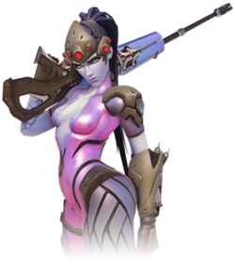](https://en.wikipedia.org/wiki/Widowmaker_(Overwatch))

### Ethnicity and Diversity

Race isn’t usually a problem in video games as not many developers touch on it as it is a very controversial issue although when developers do such as in GTA 5 and South Park: The Fractured but Whole the race being affected don’t really care as they believe it is true. As in GTA 5 depending where you are in the game the police will react differently depending on what race your character is. Also in the game South Park: The Fractured But Whole at the start of the game in the character selection when you choose the difficulty of the game to make the game harder you have to darken your skin tone although there was not much of an outrage for this as it was just a joke and didn’t actually effect the game and people though it was true.

[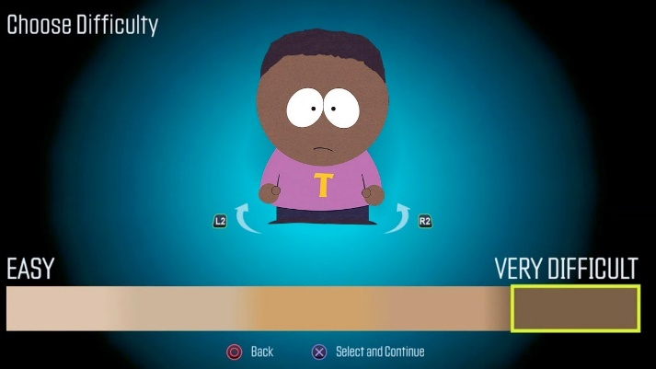](https://www.youtube.com/watch?v=oG6xFDLhO_c)

### Religion

Religion is not really touched on a lot in video games as it is always a controversial issue and if a developer were to include religion in their video game even if they represented the religion fairly there would always be people who would feel offended so there is really no benefit with including religion in a video game.

### Intellectual Property

Property rights also known as intellectual property is the property of one’s own mind. They protect a developer’s creations for example, characters, lyrics, music and software then make it so that people cannot steal their creation and claim it as their own. This makes it so if a game company buys a soundtrack for their game they cannot say they made it and redistribute it as their own.

### Computer Game Graphics

There are many different types of digital graphics that can be used to portray a different visual styles and formats for a game.

### Raster

Raster Graphics or bit maps represents an image made of an array of pixels which is resolution dependant. Raster Graphics are generally most practical for photo – realistic images, but do not scale easily without loss of quality. Common file formats – JPEG –TIFF – GIF – BMP – PNG. An example of vector graphics in video games is with the original Mario as that used bit maps to create the characters so if you zoomed in onto Mario the quality would drop massively.[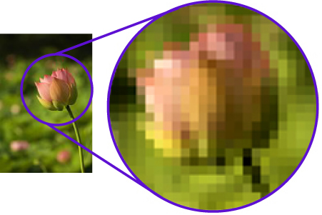](http://www.offsetprintingtechnology.com/2012/halftone-raster-reproduction/) [](https://www.reddit.com/r/AskMen/comments/4phsry/fighter_mage_thief_or_cleric_which_would_you_be/)

### Vector

Vector Graphics is the use of geometrical primitives such as points, lines, curves and shapes or polygons, which are all based on mathematical equations to represent images in computer graphics. Vector images are scalable meaning it retains its quality when zoomed in. They are made of small points named vertexes and paths. A vertex is a certain point within an image that puts a path in the given space. An example of a game that uses vector graphics is the new Mario game Super Mario Odyssey as you can zoom into the character Mario and it will stay the same quality and also as this Mario is 3D. [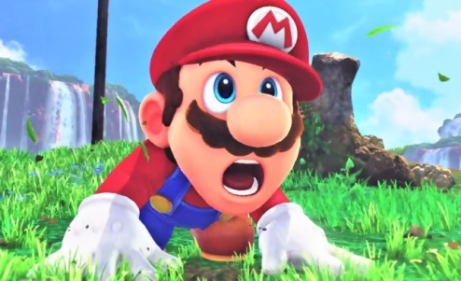](http://www.jeuxactu.com/super-mario-odyssey-trailer-de-gameplay-et-date-de-sortie-sur-switch-109745.htm)

### Head up display

Head Up Display or more commonly known as the HUD is a method of giving the user information about the character or game through images on the screen such as in the game Counter-Strike: Global Offensive. The reason it is called the HUD is because they are similar to the head-up up displays used in modern aircrafts. So from this I will put a head up display which shows the players health in my game.

As you can see the HUD in this game shows information such as how much health and armour the user has.

[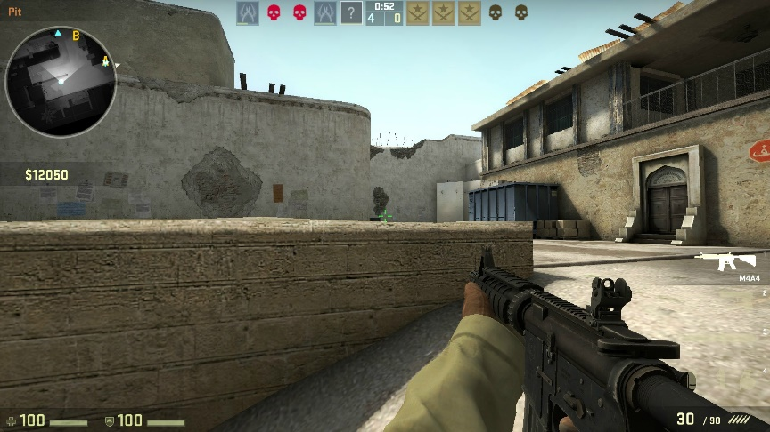](https://www.licente-jocuri.ro/counter-strike-global-offensive-steam-cd-key.html)

Also the HUD in this game presents other information to the user such as how much ammunition the user has in their gun.

### Sprites

A 2D or 3D character or object integrated in a digital graphic, it is created with bit maps or pixel art and is designed to be a part of a larger scene such as a world in a game. A sprite can be a static image or an animated graphic such as an isometric sprite. In terms of a video game an example of a sprite is any object in a game, it can range from Mario which is a 2D bit map to the flag pole/castle in Mario which is still a sprite but it just does something different. From this I now know that the player in the game I will create will be a 2D sprite and will probably be pixel art.

[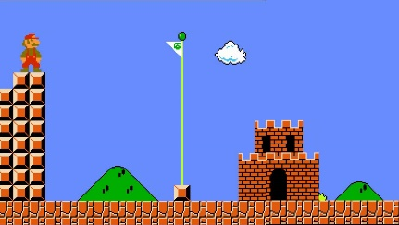](http://www.nintendo.com/games/detail/super-mario-odyssey-switch)[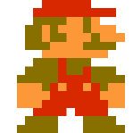](http://www.cracked.com/blog/chatting-with-mario-during-a-game-of-super-mario-brothers/)

[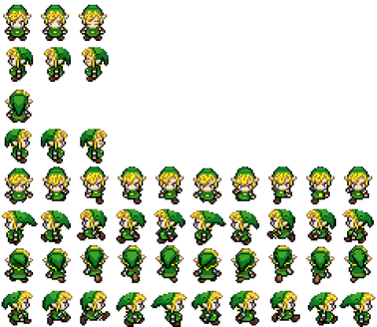](http://thomasyatesunit78.weebly.com/blog/2d-sprites)3D sprites are referred to as isomeric sprites which are basically 2D sprites that give an impression of depth to the single/player perspective isometric sprites are used in games such as Zelda. As you can see from the image it’s just a picture of Link at every angle such as front, back and side this makes it seem that Link is a 3D sprite where actually he is just a bunch of 2D sprites congregated into one. From tis I know that I my game I probably wouldn’t use isometric sprites as it is too much work to make a sprite of every movement my character would do.

### Concept Art

[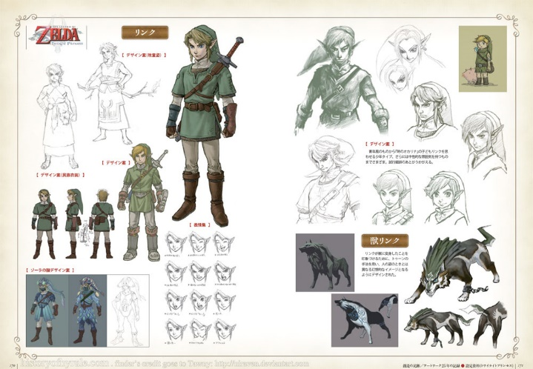](http://www.theconceptartblog.com/2012/05/07/hyhule-historia-zelda-25th-anniversary/)Concept art is used in pre-production to show ideas and in games design it is mainly used to show the developers preliminary ideas for characters and enemies in the form of drawing. Concept art is also used in films, animation and well everything which contains drawings such as architecture. Concept art is just illustrations that convey an idea, mood, character, colour scheme and or the overall style of the game. Concept art starts off as rough sketches and with time they are revisited and perfected/optimised and left as final ideas and are usually released to the public.

As you can see this picture shows the early stages of concept art and the final design for the character Link in The Legend of Zelda: Twilight Princess.

## Graphic Specification

### Client Needs

Client needs are basically what the client will want to be shown in their product/game. This could be things like a health bar or certain story elements the client wants in the game.

### Audience

Audience research is when you find out what your potential fan base/audience like and don't like for example if you are making a game you will want to find out what genre of game people like so you know if you make that game it will have potential customers as if you didn't do any audience research and made a game it could be a risk whether or not people will like it which could potentially cause a loss of money from the expenses from developing the game. Therefore, audience research is needed in the gaming industry.

### Visual Style

Photorealism

These are hand drawn images, paintings and rendered images which look very realistic to the point where they look photographic. Photorealism is used a lot in the most recent games as it has become a popular form of gaming. As technology has evolved photo realistic games have become more advanced as the graphical capabilities of computers has increased. An example of a photo realistic game is the new Project Cars 2 it aims for a truly realistic feel and experience of driving a car.

[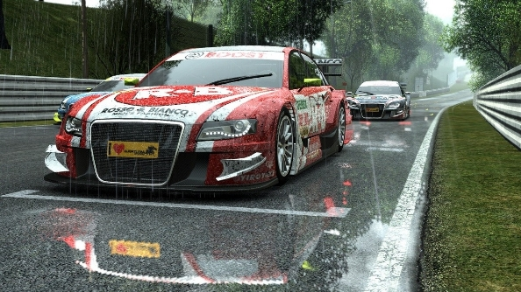](https://www.pcgamesn.com/project-cars/project-cars-2-is-now-in-full-production-by-the-entire-development-team)

Cel-Shading

This is a form of rendering that mimics the style of comic books and appears to be hand drawn. Cel-shading contains cell-like segments which can be both solid or soft shaded which is filled with highlights and dark tones. Due to cel-shadings simplicity in shading it requires less memory than a photo realistic game meaning that it is easy for a computer to render the game with no lag.

[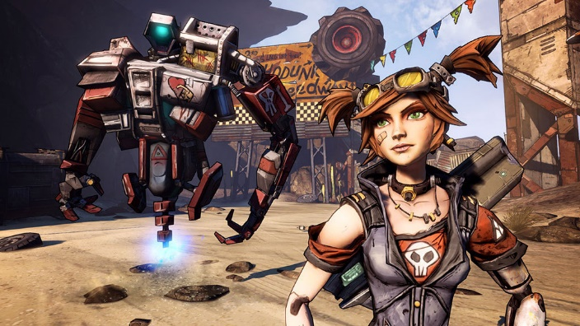](http://www.macgamestore.com/product/3544/Borderlands-2-Complete-Edition/) [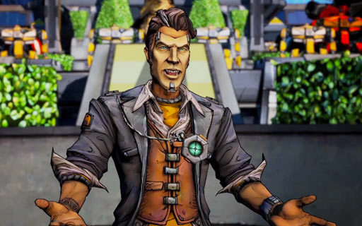](http://www.theoryofgaming.com/borderlands-2-one-year-later/)

A superb realistic cell-shaded game is Borderlands 2 introduced by the game development team “Gearbox”. The cell-shaded characters and environments in the game are highly detailed and filled with colour.

Exaggeration

This is when someone exaggerates important or easily identifiable features. This is noticeable when looking at the main character of the game series Animal Crossing. The main character from this series has an exaggerated head this is because the creator wanted the user to concentrate on the character’s head when looking at him from a bird’s eye view.

[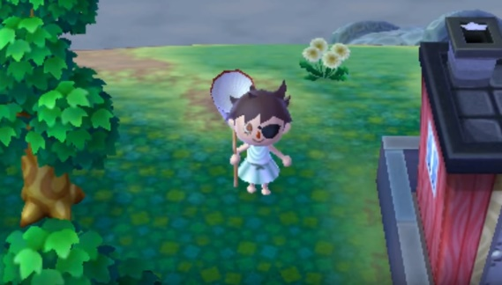](https://www.youtube.com/watch?v=RCJ_7Q8CqJ0&t=447s)[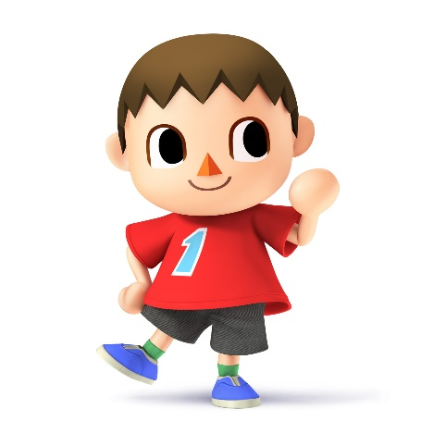](http://www.smashbros.com/en-uk/characters/villager.html)[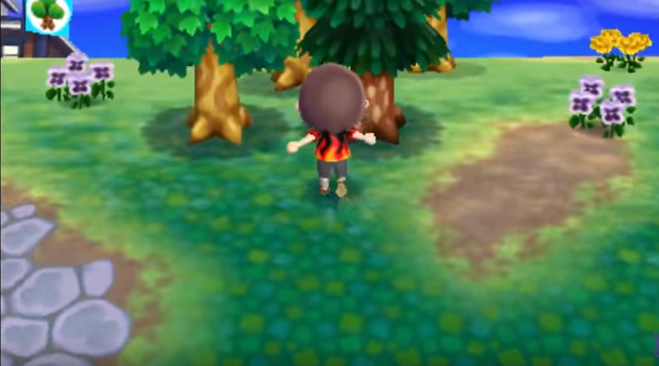](https://www.youtube.com/watch?v=RCJ_7Q8CqJ0&t=447s)

Although a game that uses exaggeration usually looks like a cartoon it is also used in most photo realistic games to portray the violence as over the top to intrigue the player and enhance their experience. An example of this type of exaggeration is shown in the game Resident Evil 4 as you can see from the picture in real life a shotgun blast to the head wouldn’t behave that way this was just implemented into the game to intrigue the player to carry on playing.

[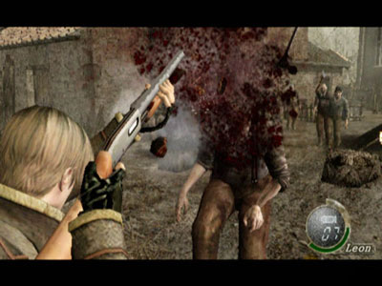](http://cube.gamespy.com/gamecube/resident-evil-4/577819p3.html)

Anime/Manga

An art style originating in Japan which often exaggerates certain features of a character’s body and has a hand-drawn quality to it. This form of art style is most certainly expressed in the anime One Punch Man with the character Saitama’s exceedingly bald round head. Another example is from the anime series Code Geass as all the characters have huge eyes.

[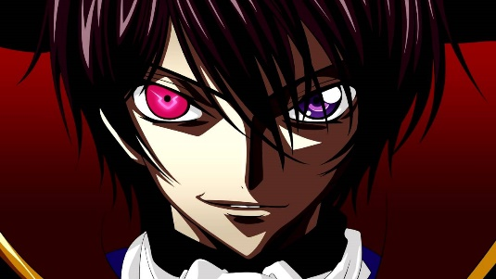](https://www.youtube.com/watch?v=ytOTwtA-Py8)[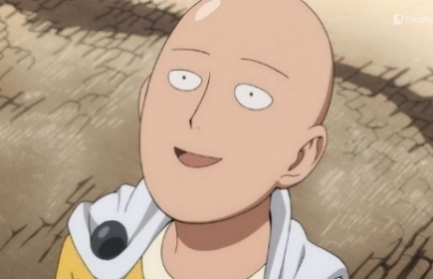](https://comicvine.gamespot.com/forums/battles-7/saitama-vs-thor-vs-superman-1800983/)

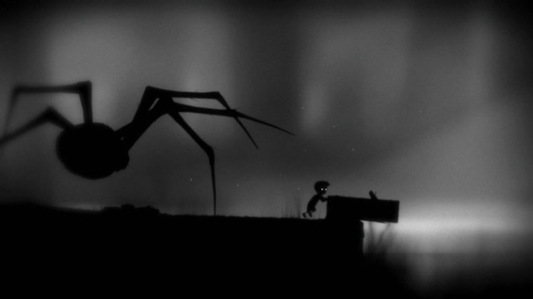Expressionism

This art style often uses symbolism and metaphors to portray physical things, concepts and emotions. Such as a black background could be portraying someone as feeling sad or depressed. The art form of expressionism originated from Germany and is used to convey certain moods, ideas and to show the world from a different perspective. An excellent use of expressionism in a video game is in the indie title Limbo in this you play as a child shrouded in darkness trying to find out what has happened from the perspective of this boy.

Realism

Looks realistic but lacking embellishment or exaggeration usually is minimalistic. Similar to phot realism but often less detail. The reason it is not detailed and lacks stylisation is because this art tries to show tings truthfully. As you can see from this image it uses the realism art form as it is not trying to look good it is simply trying to describe what is happening in the picture and that is it.[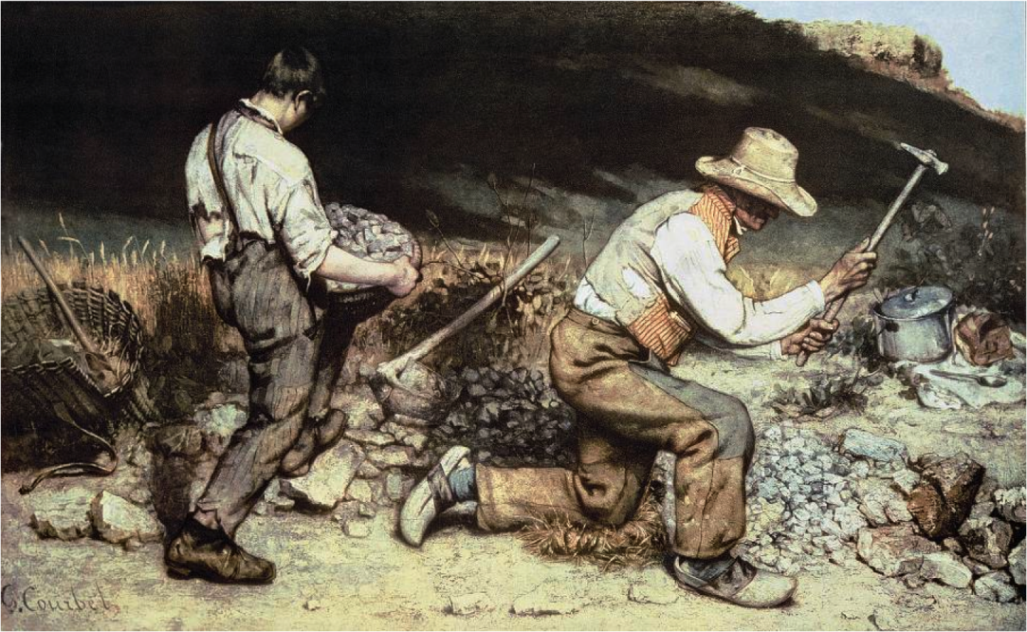](https://www.citelighter.com/art-architecture/art/knowledgecards/the-realism-art-movement)

### Technical Considerations

Storage of Image Assets

This is a main hub for everyone in a games development team to access data such as images, sounds and other documents. A lot of work is transferred through this over the internet so only small files can be sent over such as jpeg, tiff and giff files. However, if the image is large in file size for example a game texture when sent over it will be compressed and loose quality. It would usually look like this picture. [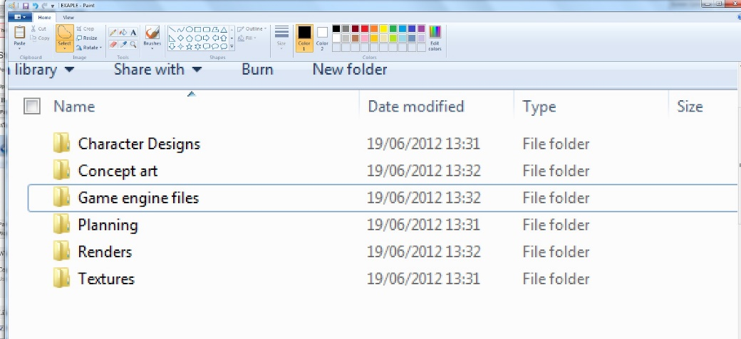](https://twinlance7.wordpress.com/unit-78/storage-of-image-assets/)

File Naming Convention

A file naming convention helps people to organise their documents making it easier to identify certain files that contain information you are looking for. A good file naming convention can help you and others working with you. A good example of a file naming convention is one my teacher told me to use and it usually looks like “L3-Y1-U78-JKR-Task 1”. So “L3” means level 3, “Y1” means year 1, “U78” means unit 78 and “JKR” are my initials. [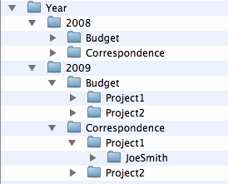](https://lsntap.org/book/export/html/2961)

Asset Management

Asset Management plays an important role in games development as if the assets are not managed and stored correctly everything will be unorganised which may result in losing work, sending incorrect files and more importantly time will be wasted trying to search for files. That’s why resources should be managed in both short term and long term.

An example of short term management is to keep the amount of windows on a browser to a minimum as if a bunch of windows were open it would be inefficient when trying to find a certain tab/piece of work causing time to be wasted which is never good in any business. Secondly the computer running the browser might not be able to handle all of the windows causing it to become slow and unresponsive and worst case scenario it could turn off causing work to be lost. Therefore, it would be more efficient to keep browser windows open to a minimum meaning there will be less clutter on the screen making it easier to manage. As you don’t want your browser to look like this.



A perfect long term management method is to make sure files are stored in the correct place to do this a library of folders should be made which are name accordingly to the content inside. This will make it easier in the work place to find certain files which are needed for work.

Another long term management method is to make regular backups of all work in case work is lost. These backups should be dated so it is apparent how old they are. Old backups that are irrelevant should of course be deleted to save space. A perfect example of why backups are important is with the movie Toy Story 2 as this movie was actually never going to be released as while working on it Pixar was near to completion when suddenly there was a server error and huge chunks of the movie was deleted and Pixar realised they couldn’t redo the movie so they were going to scrap it but luckily someone working from home had the entire film backed up on her computer and well as you know they were able to release the film in time all because of one backup.

[](http://www.onepointhosting.co.za/how-to-backup-your-data/)  
  
I acquired this information previously from an excellent YouTube channel this is the video link.

<https://www.youtube.com/watch?v=Hhr681TpZac>

# Scheduling

Version 1

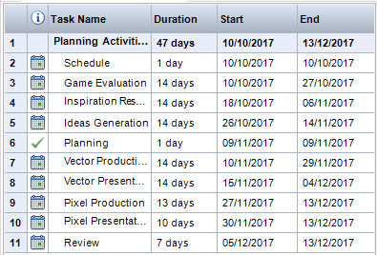This is a screenshot of my schedule created with the MindView software.

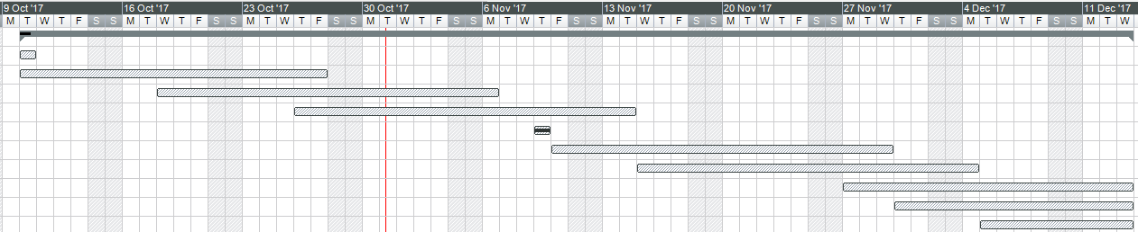

# Version 2

 =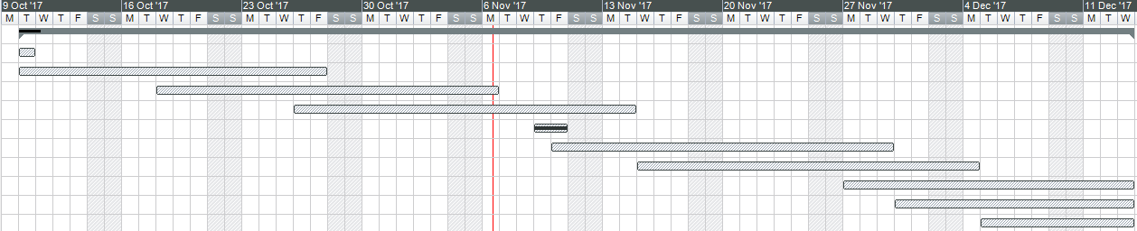

Game Evaluation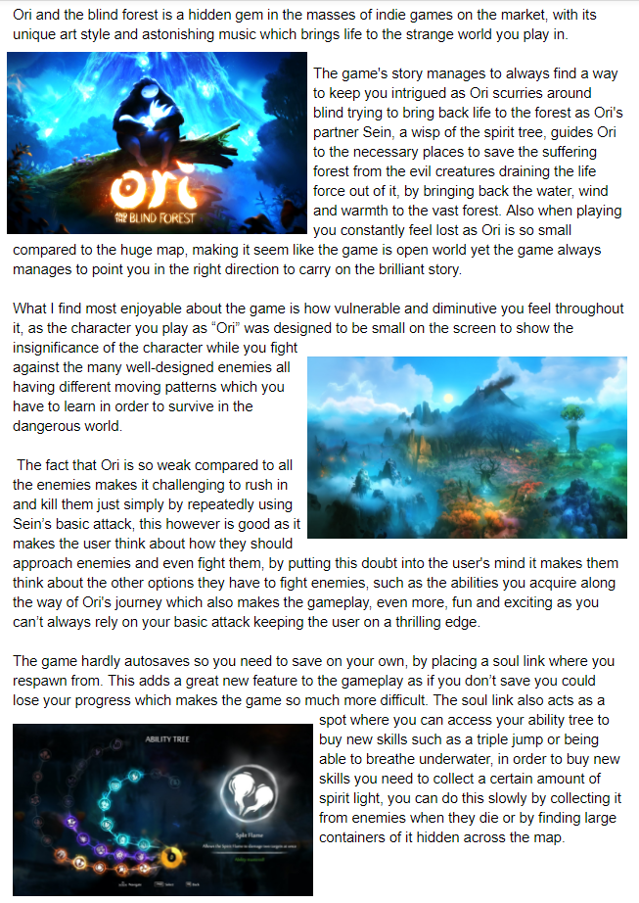 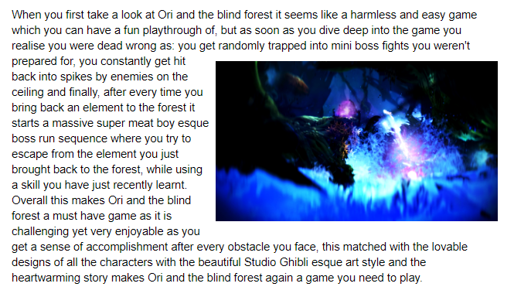

# Game Ideas

# Shanty Town Game Mood Board

Gameplay: Parkour, Obstacles/Puzzles like the game Little Nightmares where the character is so small compared to the rest of the world and you never feel safe but also like the game Inside where you have to hide from the enemies and make your way past them. In the game when necessary the child will be able to throw rocks to stun enemies or hit objects to solve puzzles.

[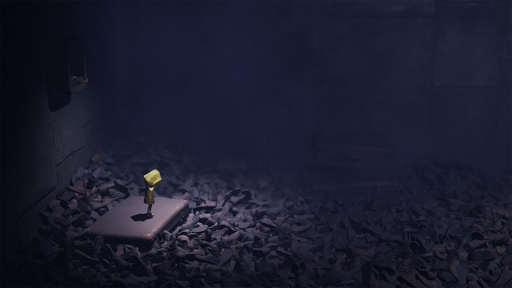](https://uk.gamesplanet.com/game/little-nightmares-steam-key--3162-1)[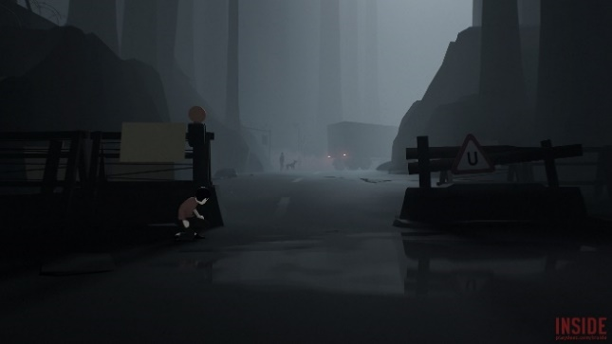](https://waypoint.vice.com/en_us/article/vvkzz8/the-unifying-monstrous-hopefulness-of-inside)

Colours: Dreary colours, brown, dark brown etcetera



Player: Young child – Silent protagonist, will wear a bright coloured t-shirt so the player can see them on the screen.

Setting: A shanty town

Target Audience: 12+

Story: The player a young child tries to steal bread from a shop keep in a shanty town and ends up getting caught, the punishment is death he has to escape and run away everyone is trying to chase him so he has to jump onto unsafe roofs and run for his life until he gets to the big city. Safety. He has to do all of this while still maintaining his health by getting food and drink, washing and well not dying from sharp objects. The boy’s objective is to make it to the big city where he has heard dreams come true and people don’t starve there. At the end of the game when the boy makes it to the big city he ends up getting finally caught by the guard who first threw him in jail he takes him to the local police station to meet his parents which the guard was trying to do in the first place. The guards and everyone calls the child boy but when he meets his parents at the end of the game he finds out his name is Mvulana which is Swahili for boy so the whole game everyone was just calling out his name to get him home safe to his parents.

[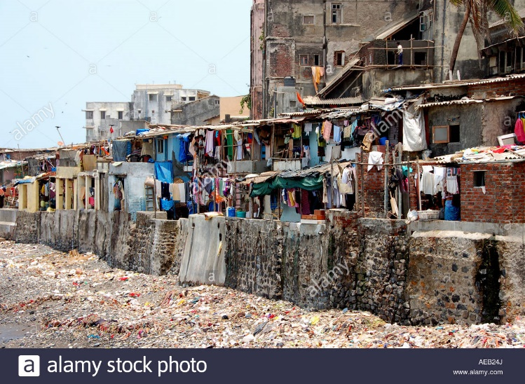](http://www.alamy.com/stock-photo-shanty-town-in-mumbai-or-bombay-viewed-from-a-taxiing-aircraft-at-78006577.html)[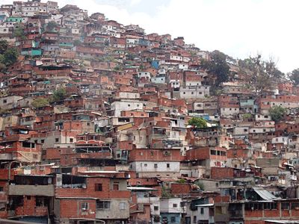](https://propertydrum.briefyourmarket.com/Article.aspx?id=558)

He would have to climb up places like this while avoiding guards and thief’s or just criminals.

Enemies: Guards who look like the picture but without the turban.

[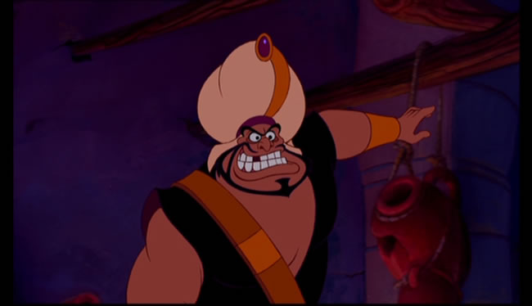](http://aladdin.wikia.com/wiki/Razoul)

Sound: You can hear the guards shouting when they come close. The falling of scrap metal. The footsteps of the young boy when he walks.

# Story Board

|  |  |
| --- | --- |
| Scene 1 | Scene 2 |
|  |  |
| Description: A young boy (the player) wakes up from sleeping on the dirty street floor. | Description: He walks around (while he player enjoys the scenery/view) and his stomach starts to rumble. |
| Scene 3 | Scene 4 |
|  |  |
| Description: The boy finds a stall selling bread but realises he has no money to pay, but his stomach continues to growl and roar. | Description: He decides to grab the bread and run but as he lays his finger on the bread the shopkeeper grabs his arm and says “Boy! Do you know what we do to thieves!” as he proceeds to pull out a big butchers knife. |
| Scene 5 | Scene 6 |
|  |  |
| Description: Suddenly a guard shouts stop and walks to the shopkeeper saying “can’t we be civilised? And lock him up?”. | Description: The guard grabs you a throws you in a cell. Then the game starts as you have to escape the cell and run away from home to the big city. |

## Idea Generation

Idea generation is what is needed to get the initial concept of a game and there are several ways to portray these ideas.

### Brainstorming

Brainstorming is when multiple ideas are jotted down usually on a piece of paper and then elaborated until you finally choose which idea you like best. They are usually called spider diagrams with the way they are set out.

[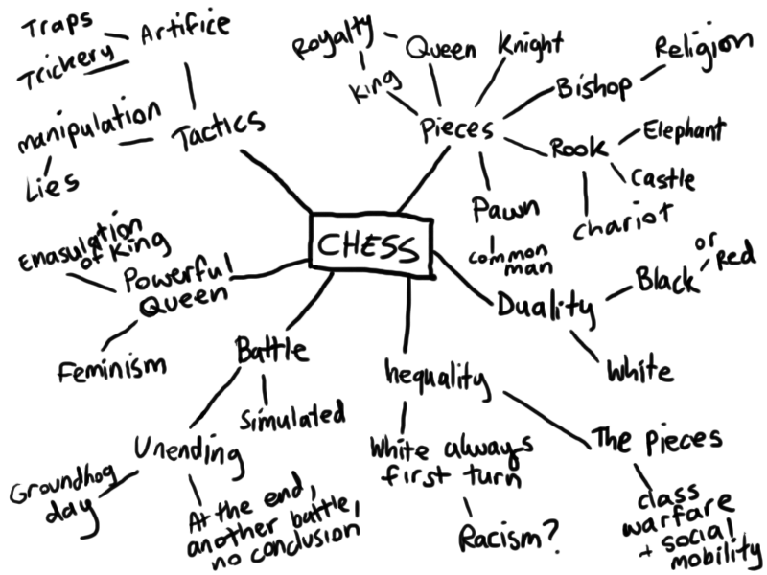](http://www.indiemanga.com/articles/)

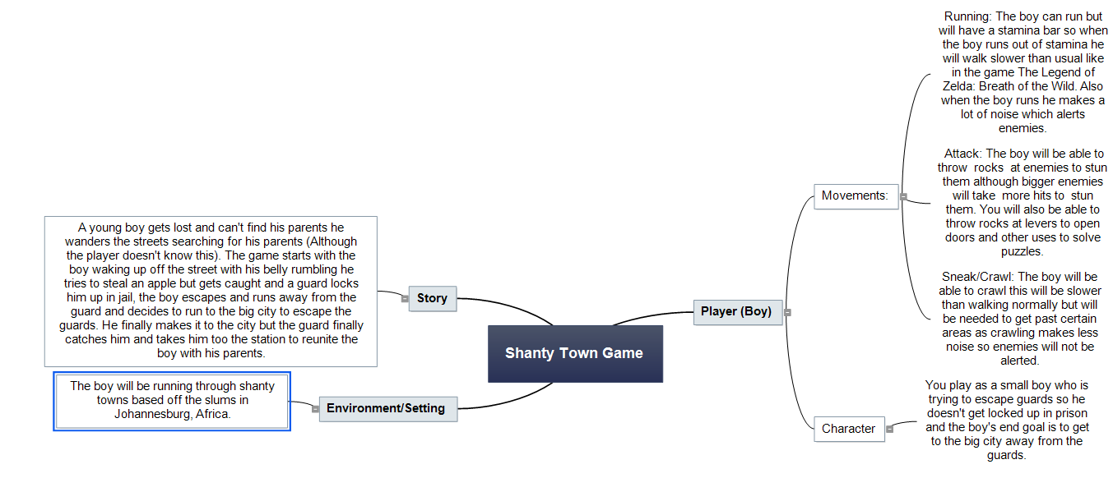This is my own spider diagram which I made for a game called Boy.

### Mood Board

A mood board is a display of what the creator is thinking about their idea, this could contain the colours he would use for a game a basic concept for the gameplay and story to get the developers and viewers minds stimulating for what the game could feel and pay like. They usually look like this and have writing at the bottom explaining it.

[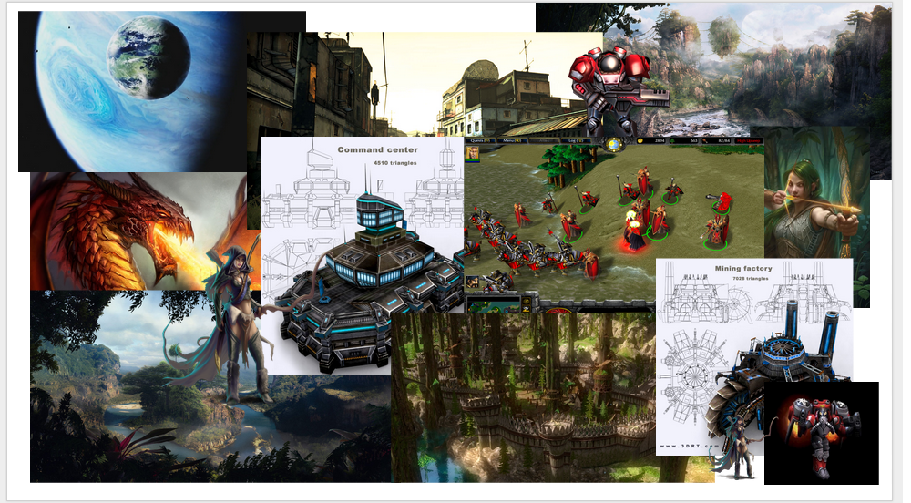](https://euwinjohnatkins.wordpress.com/game-project-3/05-moodboard/)

### Thumbnail Sketching/Storyboard

Thumbnail sketching also known as a story board are brief concepts of a game such as character ideas, story and setting. These ideas could stay with the game or could be terminated from the final concept. For example, this is thumbnail sketching for the Mario games as it shows how Bowser Jr will move and how various other enemies will move.

[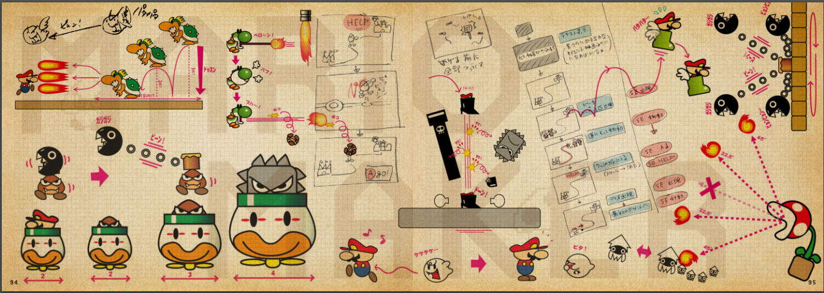](https://supermariomaker.nintendo.com/assets/SuperMarioMakerIdeaBook.pdf)